**MYSQL TASK- Guvi_ZEN DB model**

**EER diagram**:

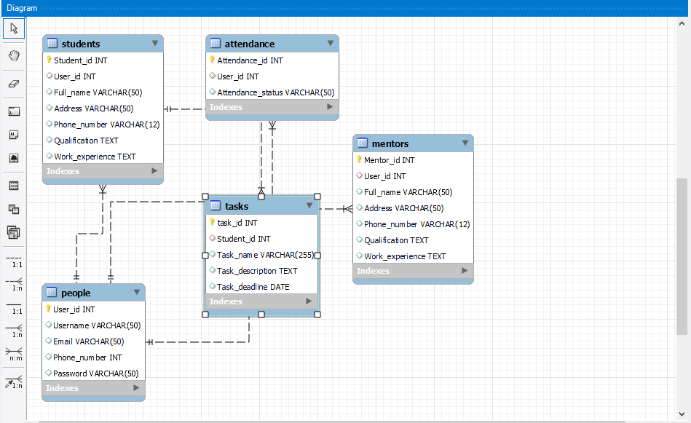

**Queries**:

CREATE DATABASE Guvi_Zen;

USE Guvi_Zen;

CREATE TABLE People(User_id INT PRIMARY KEY,Username VARCHAR(50),Email VARCHAR(50), Phone_number INT, Password VARCHAR(50));

CREATE TABLE Students(Student_id INT PRIMARY KEY,User_id INT,Full_name VARCHAR(50),Address VARCHAR(50),Phone_number VARCHAR(12),Qualification TEXT,Work_experience TEXT,FOREIGN KEY (User_id) REFERENCES People (User_id));

CREATE TABLE Mentors(Mentor_id INT PRIMARY KEY,User_id INT,Full_name VARCHAR(50),Address VARCHAR(50),Phone_number VARCHAR(12),Qualification TEXT,Work_experience TEXT,FOREIGN KEY (User_id) REFERENCES People (User_id));

CREATE TABLE Tasks(Task_id INT PRIMARY KEY,Student_id INT,Task_name VARCHAR(255),Task_description TEXT,Task_deadline DATE,FOREIGN KEY (Student_id) REFERENCES Students (Student_id));

CREATE TABLE Attendance(Attendance_id INT PRIMARY KEY,User_id INT,Attendance_status VARCHAR(50),FOREIGN KEY (User_id) REFERENCES People (User_id));